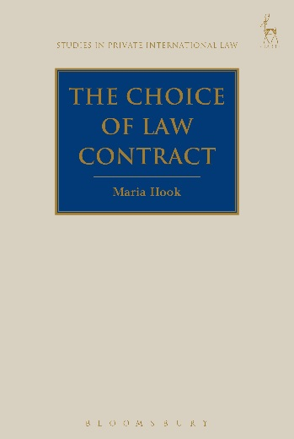
The Choice of Law Contract
Maria Hook

This book offers a contractual framework for the regulation of party autonomy in choice of law. The party autonomy rule is the cornerstone of any modern system of choice of law; embodying as it does the freedom enjoyed by parties to a cross-border legal relationship to agree on the law applicable to it. However, as this study shows, the rule has a major shortcoming because it fails to give due regard to the contractual function of the choice of law agreement. The study examines the existing law on choice of law agreements, by reference to the law of both common and civil law jurisdictions and international instruments. Moreover, it suggests a new coherent approach to party autonomy that integrates both the law of contract and choice of law. This important new study should be read with interest by private international law scholars.

Maria Hook is a Lecturer in Law at the University of Otago.

September 2016 | 9781849467643 | 288pp | Hardback | RSP: £60
Discount Price: £48

Click here to order online – use discount code CV7 at the checkout to get 20% off

